OUTPUT SCREEN SHOTS
Project Title: Server Monitoring
OUTPUT SCREEN SHOTS
Project Title:- Managing tightly coupled architecture using Amazon SQS
- Step 1: Create MySQL Database using RDS Service.
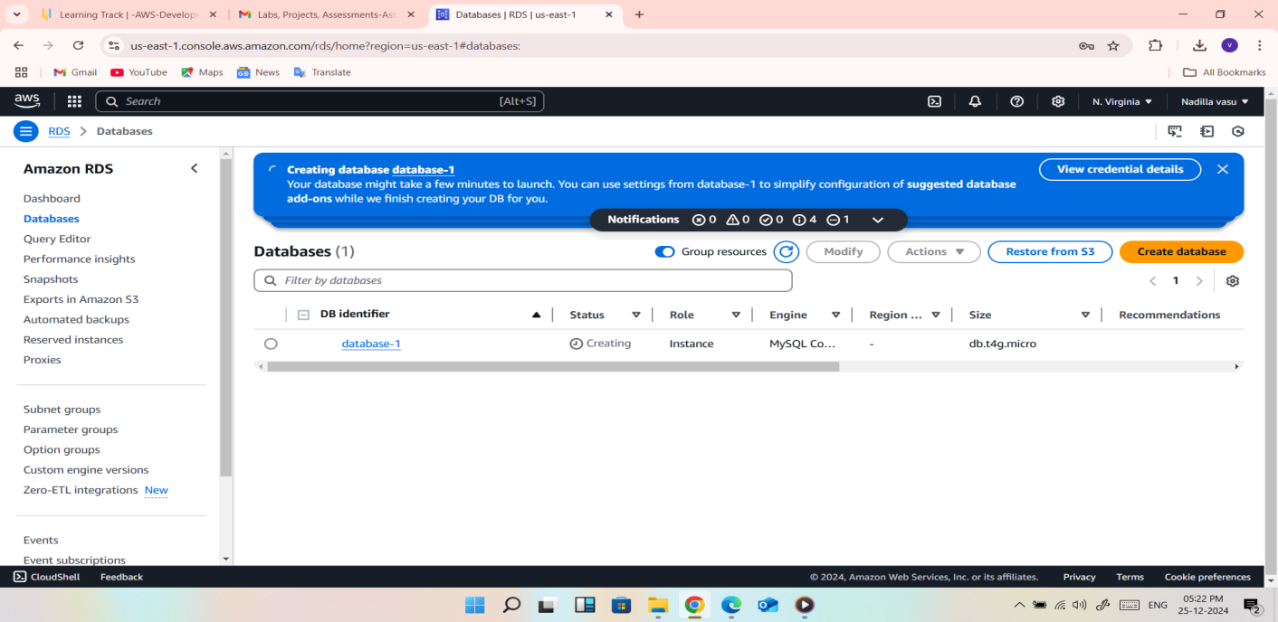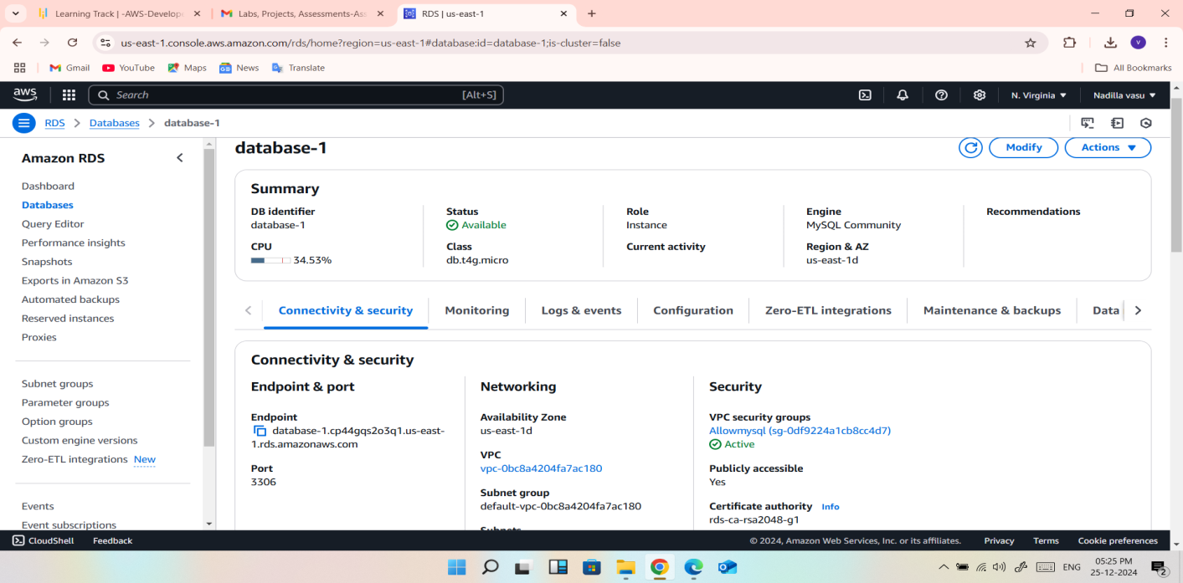
STEP:- Create SQS Queue.
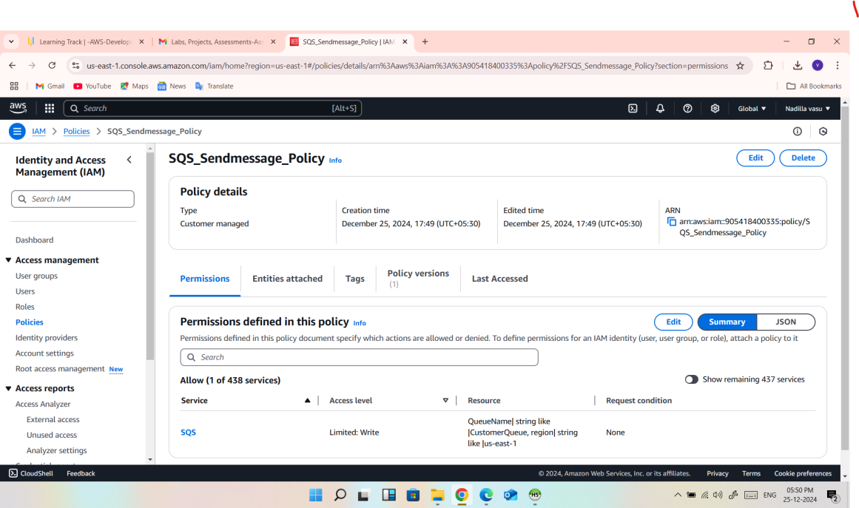
STEP 3: Connect through SQL Client and create a table. 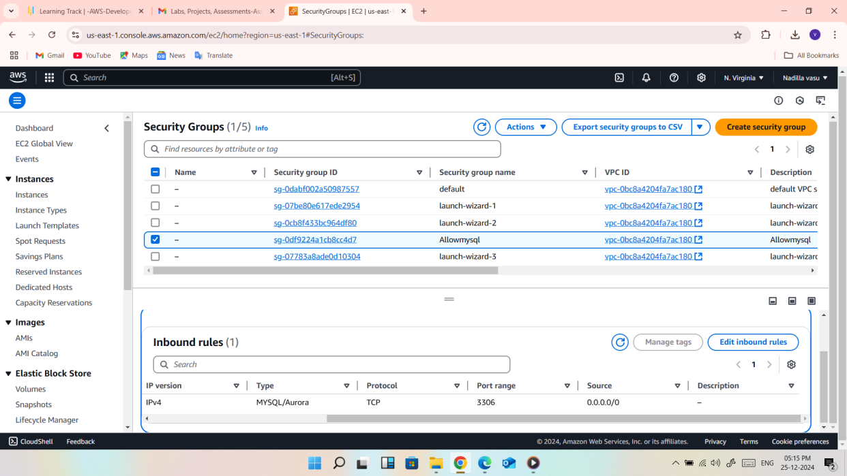 4: Create a user for an employee of the company who requires administrator access to the company's AWS account, and then add the user to the Administrator Group.
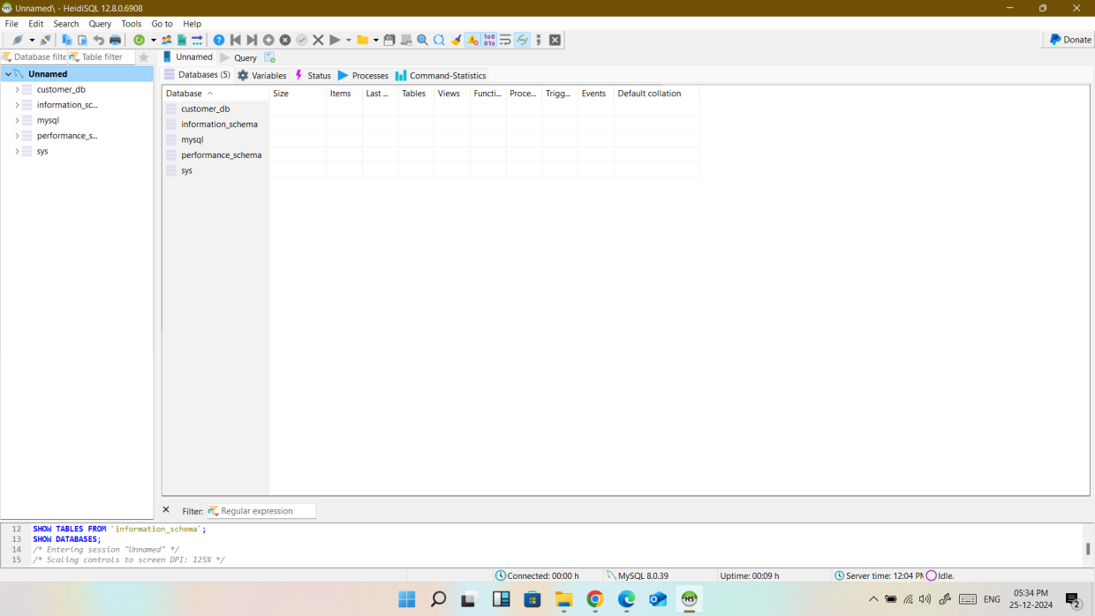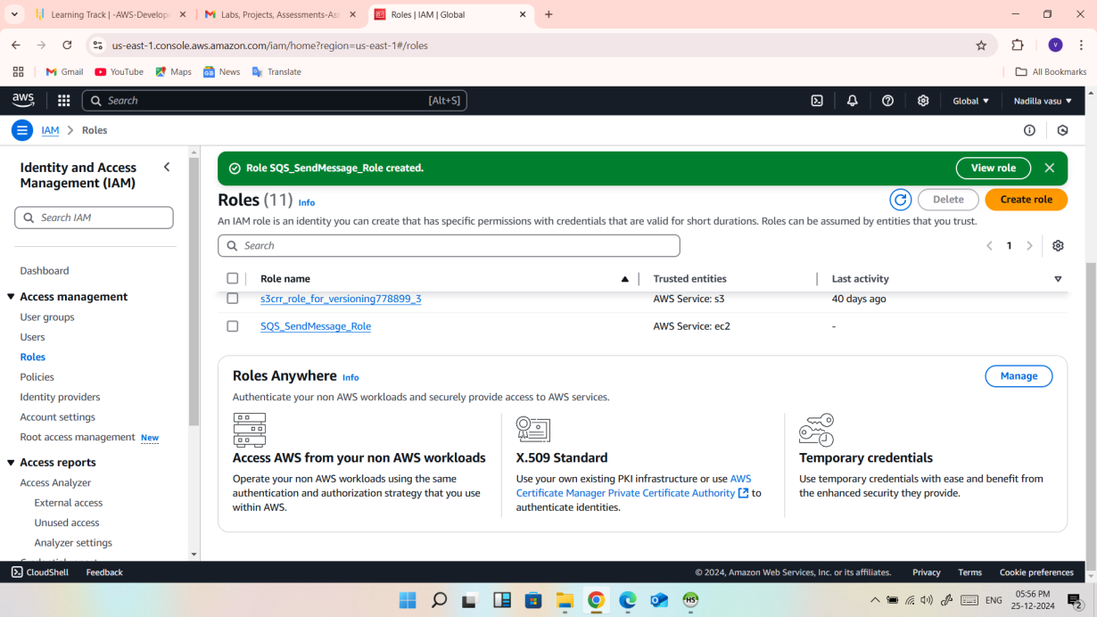
4. Create a frontend and backend server using EC2 instance
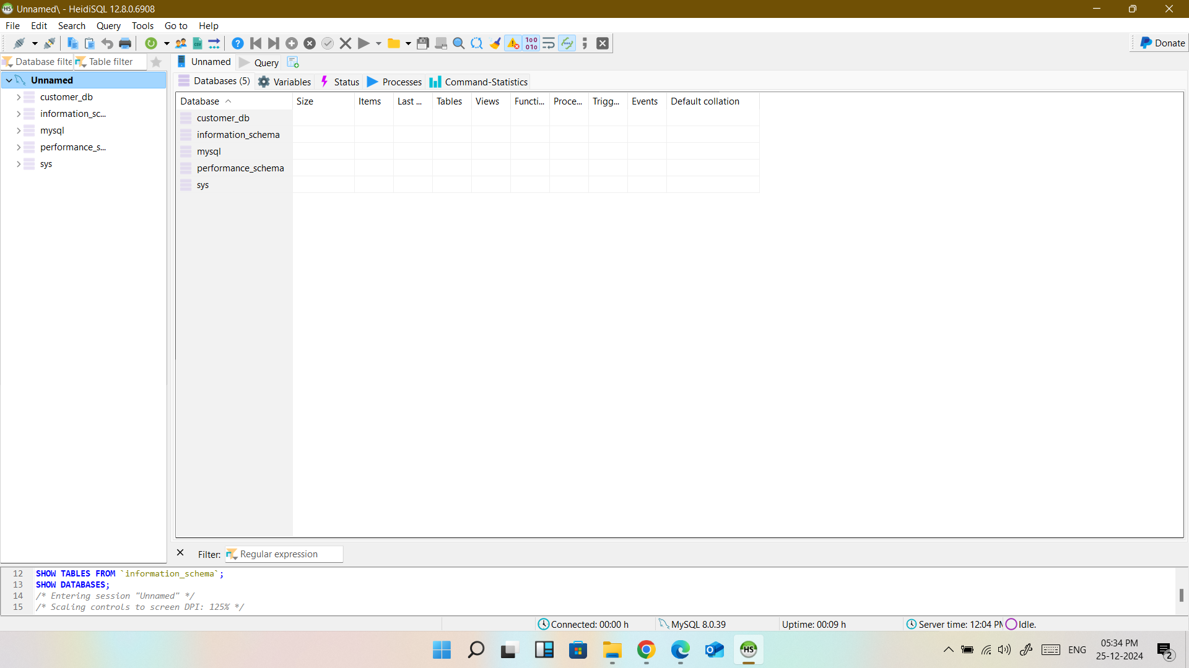
5. Connect the SQS queue with the front end server to insert entries into MySQL dB in RDS service
